AI FIT TRACK
AI-Powered Fitness and Workout Management System
PROJECT DOCUMENTATION

TEAM ID : SWTID - 2026 - 9479
TEAM SIZE :4
ROLE | NAME | MAIL ID
TEAM LEADER | POORVAJA.R | poorvaja2006@gmail.com
TEAM MEMBER | POORNITHA.R | poornithapoornitha507@gmail.com
TEAM MEMBER | POOJA.S | poojadee23@gmail.com
TEAM MEMBER | POOJASRI SURESHBABU | poojasri.sbabu@gmail.com
TEAM MEMBERS

AI FitTrack -- Personalized Fitness Tracking and AI-Powered Recommendations
PROJECT DESCRIPTION:
AI Fit Track is an AI-powered fitness and workout management web application developed using the MERN stack (MongoDB, Express.js, React.js, and Node.js), integrated with Artificial Intelligence capabilities using Google Gemini AI. The system enables users to manage their fitness activities, receive personalized workout recommendations, track fitness progress, and obtain AI-generated fitness insights based on their age, fitness goals, and experience level. By combining traditional web application development with modern AI technologies, the platform provides an intelligent, interactive, and user-friendly fitness experience that promotes personalized workout planning, progress monitoring, and effective fitness management.
SCENARIO:
Problem:
In today's world, many individuals face difficulties in maintaining their fitness and following proper workout routines. Users often struggle to find suitable exercises, set fitness goals, and track their daily workout progress. Traditional fitness applications provide general workout plans that may not match individual fitness levels, age, and experience. Beginners also lack proper guidance and find it difficult to choose appropriate exercises and maintain consistency in their fitness journey.

AI Solution:
AI Fit Track is an AI-powered fitness and workout management web application developed using the MERN stack and integrated with Google Gemini AI. The application uses Artificial Intelligence to analyze users' age, fitness goals, and experience levels to generate personalized workout recommendations and fitness insights. It provides AI-powered assistance to answer fitness-related questions, suggest suitable exercises, and generate workout plans based on individual requirements. The system also enables users to manage their fitness profiles, record workout activities, and monitor their progress efficiently

Impact:
AI Fit Track benefits fitness beginners, regular workout enthusiasts, and individuals who want to maintain a healthy lifestyle. It simplifies workout planning, reduces the need for manual fitness management, and provides personalized guidance based on user requirements. By combining AI-powered recommendations, fitness insights, and workout tracking in a single platform, the application improves accessibility, supports informed fitness decisions, and helps users maintain consistency in achieving their fitness goals.

SYSTEM REQUIREMENTS:
AI FitTrack requires software and hardware resources for application development, database management, authentication, and AI processing. A stable development environment and internet connection are required because the application communicates with Google Gemini AI.

1. Software Requirements
Operating System: Windows 10/11, macOS, or Linux can be used for development and execution.
Node.js (v18 or above): Provides a runtime environment for backend development and execution of JavaScript code npm (v9 or above): Package manager used for installing and managing project dependencies

Express.js: Backend framework used for developing RESTful APIs and handling authentication, workout management, and AI requests

MongoDB: NoSQL database used to store:

- User Information and Fitness Profiles
- Workout Details and Activity Records
- Fitness Goals and Progress
- Authentication Data and JWT-related user information
- AI-Generated Workout Recommendations
- AI Fitness Insights

Mongoose: Provides schema definition, validation, and communication between Node.js and MongoDB.
Google Gemini AI: Used to generate personalized workout recommendations and AI-powered fitness insights based on user details and workout history.
Postman: Used for testing and validating RESTful APIs, including authentication, workout management, and AI recommendation endpoints
Visual Studio Code: Development environment used for writing, editing, debugging, and managing the project source code.

2. Hardware Requirements
Processor: Intel Core i5 (8th Gen or above) / AMD Ryzen 5 or above.
RAM: Minimum 8 GB (16 GB recommended for concurrent instances of MongoDB and AI processing).
Storage: Minimum 5 GB free space for project files, dependencies, and development tools.
Internet Connection: Required for Google Gemini API communication, MongoDB Atlas connectivity, and application access.

PROJECT ARCHITECTURE
AI Fit Track follows a modular, layered architecture in which each component performs specific functions, making the application easier to develop, maintain, test, and upgrade.
The backend handles user requests, authentication, and workout management, while MongoDB stores user profiles, workout records, and fitness data. JWT authentication and middleware secure protected routes. The Google Gemini AI component analyzes user details and workout information to generate personalized workout recommendations and fitness insights, providing an efficient and user-friendly fitness management system.
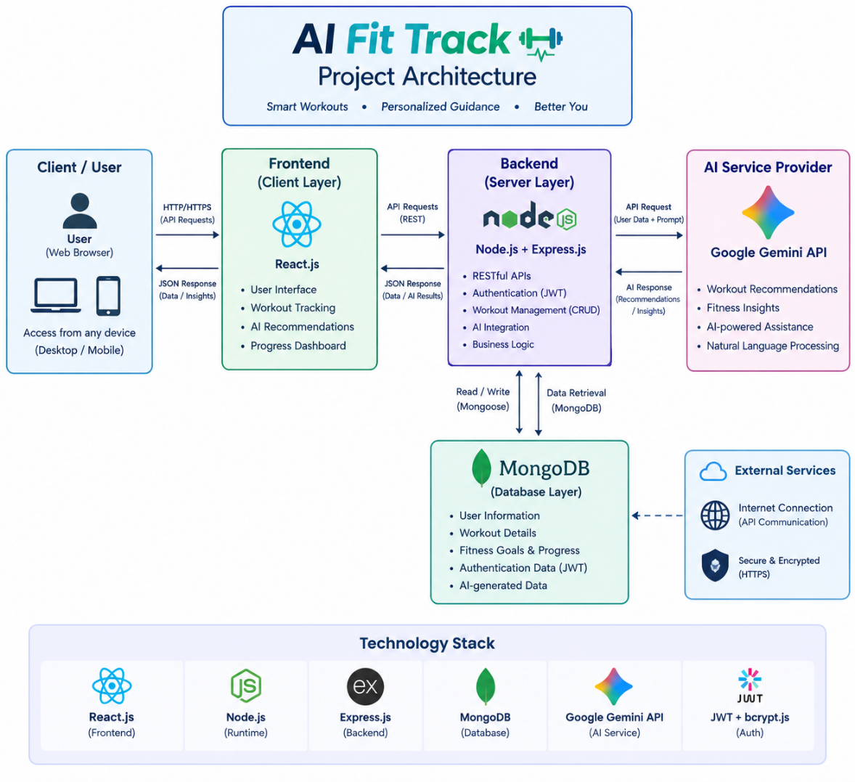

Technical Architecture
The major components of the AI FitTrack architecture are described below.

1. Backend Layer
The backend layer receives requests from the client, processes application logic, communicates with the MongoDB database and Google Gemini AI service, and returns JSON responses. It handles user registration, login, JWT authentication, workout CRUD operations, workout search, and AI-powered workout recommendations and fitness insights.

2. Database Layer
MongoDB is used to store user details, fitness profiles, workout records, and fitness progress. Mongoose is used to define schemas, validate data, and perform database operations efficiently.

3. AI Layer
Google Gemini AI analyzes user profile information, fitness goals, experience levels, and workout statistics to generate personalized workout recommendations and fitness insights. It provides suitable exercise suggestions, fitness guidance, and progress-based insights to help users manage their workouts and achieve their fitness goals.

4. Security Layer
Security in AI Fit Track is implemented using JWT authentication, bcrypt password hashing, protected routes, and authentication middleware. Input validation ensures that user data is properly checked before processing, helping protect user accounts and maintain secure access to fitness information.

5. API Testing Layer
Postman is used to test and validate the major REST APIs of AI Fit Track, including User Registration, Login, Get Profile, Workout CRUD operations, AI Workout Recommendations, and AI Fitness Insights. It helps verify API responses, status codes, authentication, and overall backend functionality.
Architecture Flow:
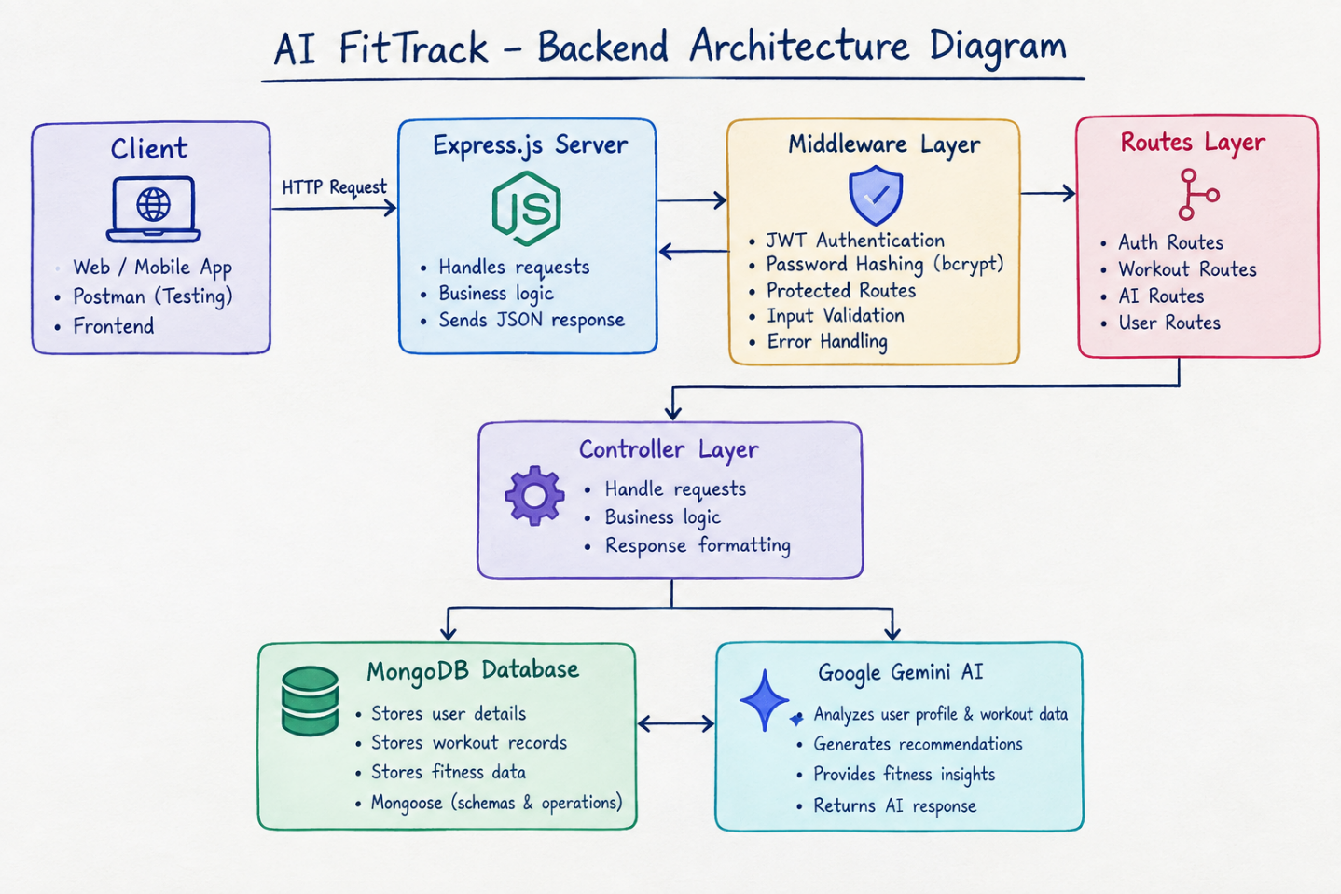
Fig1. AI-FitTrack Architecture Flow

ER DIAGRAM
The Entity-Relationship Diagram represents how information is organized within the AI FitTrack database. The major entities are User and Workout.
User Entity:
The User entity stores the details of registered users.
Main attributes:
- _id -- Unique identifier for each user
- name -- Name of the user
- email -- Registered email address
- password -- Password stored in hashed form using bcrypt
- createdAt -- Account creation date and time
- updatedAt -- Last updated date and time
Workout Entity:
The Workout entity stores the workout records created by users.
Main attributes:
- _id -- Unique identifier for each workout
- user -- Reference to the user who created the workout
- workoutName -- Name of the workout
- category -- Workout category
- duration -- Duration of the workout in minutes
- caloriesBurned -- Calories burned during the workout
- workoutDate -- Date the workout was performed
- createdAt -- Date and time when the workout was created
- updatedAt -- Last updated date and time

Relationship
A one-to-many relationship exists between the User and Workout entities in AI Fit Track. A single user can create and manage multiple workout records, while each workout belongs to a specific user. This relationship helps maintain separate workout histories and ensures that authenticated users can access and manage only their own workout records.
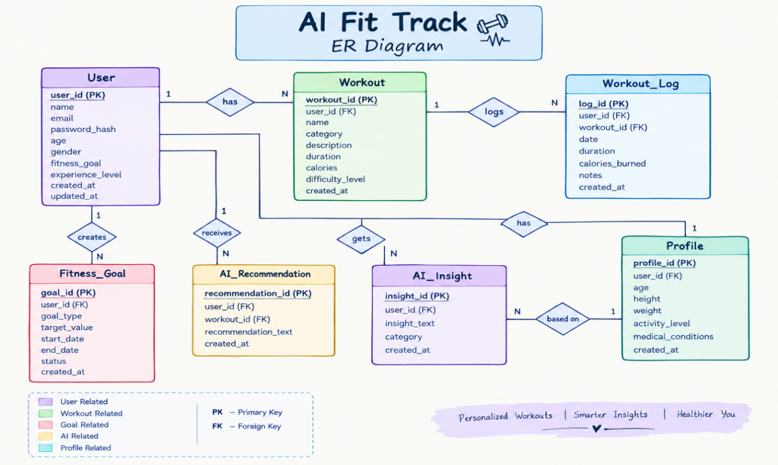
Fig2. AI-FitTrack ER Diagram

ER DIAGRAM EXPLANATION
The ER diagram of AI Fit Track represents the relationships between Users, Workouts, Workout Logs, Fitness Goals, AI Recommendations, AI Insights, and Profiles. It illustrates how user information and fitness activities are organized and stored in the MongoDB database.
The User entity stores personal details, fitness goals, and experience levels. Users can manage multiple workouts, track workout history, and maintain their fitness goals. The Workout and Workout Log entities store exercise details, duration, calories burned, and workout dates to monitor fitness progress.
The AI Recommendation and AI Insight entities store personalized workout suggestions and fitness insights generated using Google Gemini AI based on users' age, fitness goals, experience, and workout history. Overall, the ER diagram explains how AI Fit Track manages fitness data and provides personalized recommendations and insights to help users achieve their fitness goals.

FEATURES:
AI Fit Track consists of several features that work together to provide an efficient fitness management system. The main features include user management, secure authentication, workout tracking, workout search, fitness profile management, AI-powered workout recommendations, and personalized fitness insights. These features help users manage their workouts, monitor fitness progress, and receive personalized guidance through Google Gemini AI.

Core Backend Features
User Registration: Allows new users to create an account by providing their name, email address, and password, enabling secure access to the AI Fit Track application.
User Login: Allows registered users to log in using their email address and password. Upon successful authentication, a JWT token is generated to provide secure access to protected routes and user-specific fitness data.
JWT Authentication: JWT authentication verifies registered users and secures protected API routes, ensuring that only authenticated users can access their personal fitness profiles and workout records.
Password Hashing: User passwords are securely hashed using bcrypt.js before being stored in MongoDB, helping protect sensitive login information.
Workout Management: Authenticated users can create, view, update, and delete their workout records, enabling efficient workout management and fitness progress tracking.
Workout Search: Allows users to search their workout history by workout name, category, or date for easy access to their fitness records.
MongoDB Integration: MongoDB securely stores user information, fitness profiles, and workout records, ensuring efficient data management and retrieval.
REST API Support: The application uses HTTP methods such as GET, POST, PUT, and DELETE to perform backend operations, including retrieving, creating, updating, and deleting workout records.
AI Features:
AI Workout Recommendation: Google Gemini AI analyzes the user's age, fitness goal, and experience level to generate personalized workout recommendations and suitable exercise plans.
AI Fitness Insights: Google Gemini AI analyzes workout statistics, including total workouts, average duration, and calories burned, to generate personalized fitness insights, performance summaries, and motivational guidance.
AI-Powered Fitness Guidance: Converts raw workout data into meaningful fitness insights, helping users understand their performance and improve their exercise routines.

ROLES AND RESPONSIBILITIES

Registered User
The registered user is the primary user of AI Fit Track. Users can create an account, log in securely, manage and search workout records, track fitness activities, and receive AI-generated workout recommendations and personalized fitness insights.
The main responsibilities of the user include:
- Registering and logging into the system securely.
- Accessing protected APIs using JWT authentication.
- Adding, viewing, updating, and deleting workout records.
- Searching workout history by name, category, or date.
- Requesting AI-generated personalized workout recommendations.
- Obtaining AI-powered fitness insights based on workout statistics.
- Managing personal fitness information and tracking workout progress.

System / Backend
The backend manages all application operations and coordinates communication between MongoDB and Google Gemini AI.
Its main responsibilities include:
- Validating registration and login requests
- Hashing passwords using bcrypt.js
- Generating and verifying JWT tokens
- Managing workout data
- Sending profile and workout information to Gemini AI
- Returning structured JSON responses
- Handling invalid requests and API errors safely

USER FLOW
The user flow explains how a user interacts with AI FitTrack from account creation to receiving workout recommendations and AI-generated insights.
- User Registration – A new user can register by providing their name, email address, and password to create an account in AI Fit Track.
- User Login -- The registered user logs in using their email address and password to access their AI Fit Track account securely.
- JWT Authentication -- The backend generates a JWT token upon successful login, allowing the user to securely access protected APIs.
- Manage Workouts -- The authenticated user can add, view, update, delete, and search workout records by name, category, or date to manage fitness activities efficiently.
- Submit Profile Information -- The user provides their age, fitness goal, and experience level to receive personalized workout recommendations from Google Gemini AI.
- Generate AI Recommendation -- Google Gemini AI analyze the user's profile information and generates a personalized workout plan based on their fitness goals and experience level.
- Submit Workout Statistics -- The user provides workout statistics, including total workouts, average duration, and calories burned, which Google Gemini AI analyze to generate personalized fitness insights and performance recommendations.
- Generate AI Fitness Insight -- Google Gemini AI analyzes the workout statistics and generates personalized fitness insights, performance summaries, and improvement suggestions.
- Return Response -- The backend returns workout data, personalized recommendations, or fitness insights to the user in JSON format.

User Flow Representation:
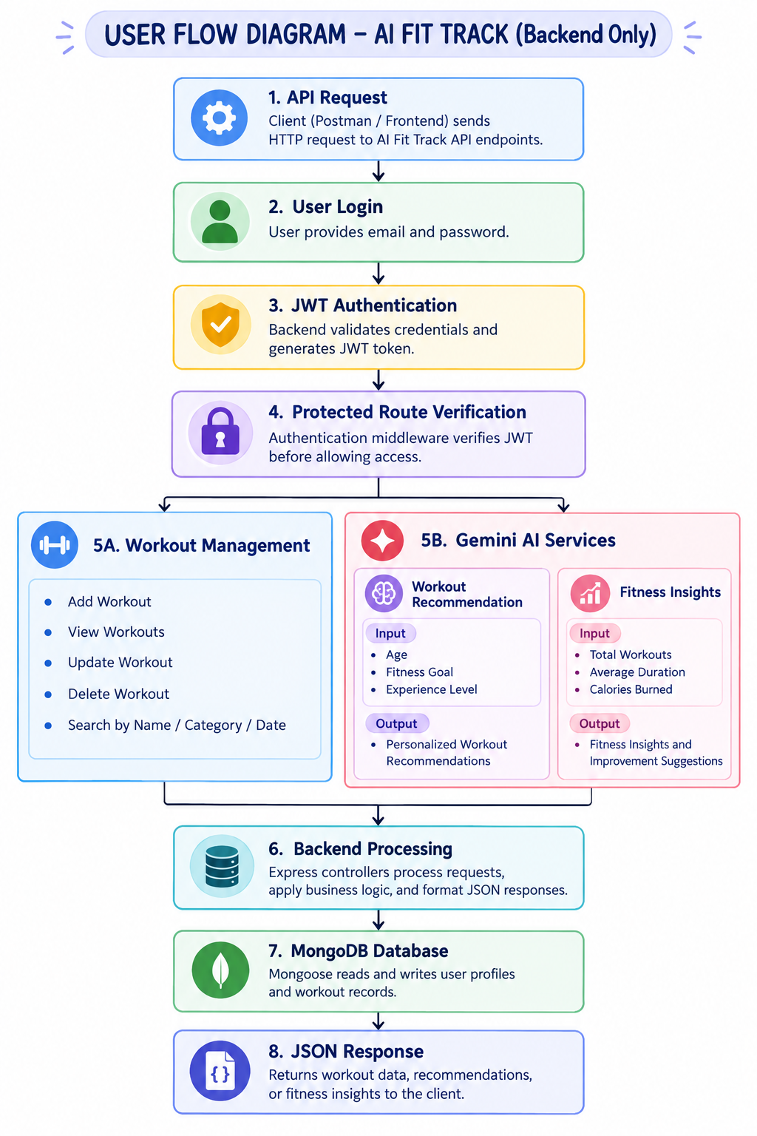

MVC PATTERN
AI Fit Track follows the Model-View-Controller (MVC) architecture to separate backend responsibilities into different components. This structure organizes the source code, simplifies maintenance, and allows individual components to be developed and tested independently.

Model Layer
The Model layer defines the data structure and schemas for storing user information and workout records in MongoDB using Mongoose. It also handles database operations and data validation.
Main models:
User.js -- Stores user details, including name, email, hashed password, and other relevant account information in MongoDB.
Workout.js -- Stores workout details, including workout name, category, duration, calories burned, workout date, and the associated user reference in MongoDB.

Controller Layer
The Controller layer contains the main business logic.
authController.js -- Handles user registration, login, JWT token generation, and profile retrieval to ensure secure user authentication and account management. workoutController.js -- Handles workout creation, retrieval, updating, deletion, and search operations to enable efficient workout management and tracking.
aiController.js -- Handles AI-powered workout recommendations and fitness insights by processing user profile information and workout statistics through Google Gemini AI.

View Layer / Routes
The route files define the API endpoints used by the AI Fit Track application.
- authRoutes.js – Handles user registration, login, and profile retrieval.
- workoutRoutes.js – Manages workout CRUD and search operations.
- aiRoutes.js – Handles AI-powered workout recommendations and fitness insights.

Service Layer
- geminiService.js – Communicates with Google Gemini AI to generate personalized workout recommendations and fitness insights.
- jwtService.js – Generates and verifies JWT tokens for secure user authentication.
- passwordService.js – Hashes user passwords using bcrypt.js and compares them during login for secure authentication.

Middleware Layer
authMiddleware.js -- Verifies JWT tokens and protects private API routes, ensuring that only authenticated users can access their personal fitness data and workout records.

Advantages of MVC
The MVC architecture improves code organization, simplifies debugging, promotes code reusability, and makes future enhancements and maintenance of AI Fit Track easier.
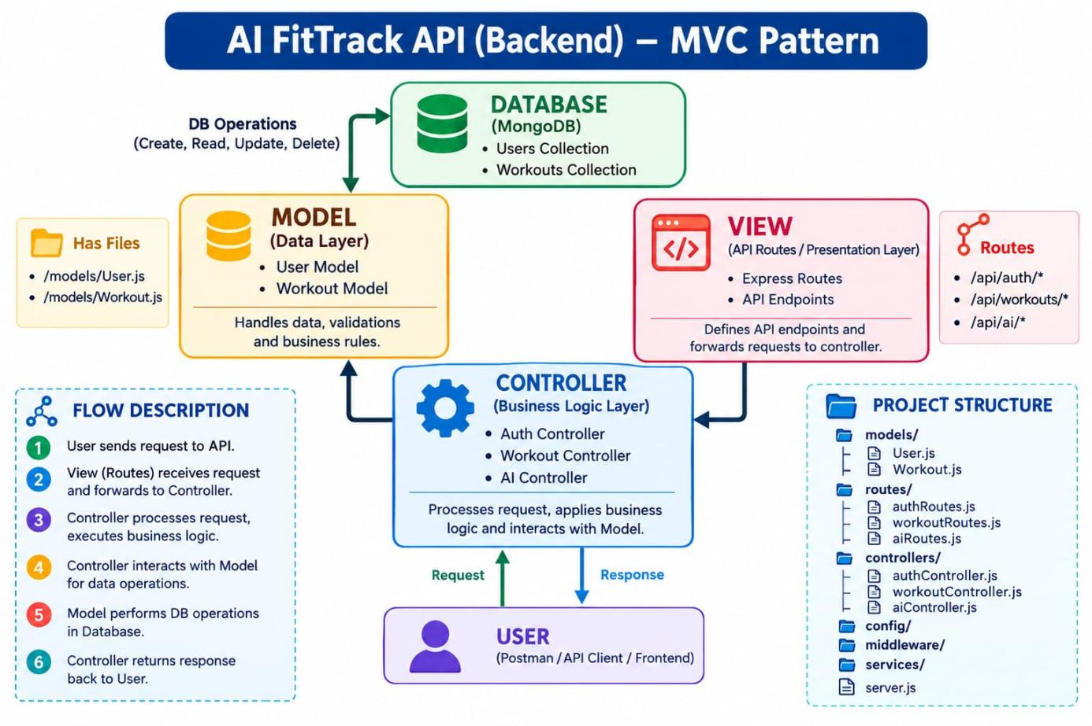

PROJECT SETUP AND CONFIGURATION
AI Fit Track is organized into separate folders for configuration, models, controllers, routes, middleware, and services. This modular structure improves code organization, simplifies debugging, and makes the backend easier to maintain, test, and extend with new features.

Project Structure
The backend source code is maintained inside a dedicated server folder.
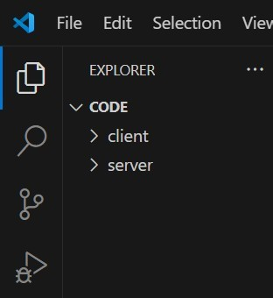

Project Initialization
The AI Fit Track backend project was initialized using npm in the server folder with the following command:
npm init -y
This command generates the package.json file, which contains project information, manages dependencies, and defines scripts required to run and maintain the backend application.

Installation of Backend Packages
The required backend packages were installed using npm to support API development, database connectivity, authentication, and AI integration.
The following command was used:
npm install express mongoose dotenv bcryptjs jsonwebtoken cors @google/genai
These packages support REST API development, MongoDB connectivity, environment variable management, password hashing, JWT authentication, cross-origin requests, and Google Gemini AI integration.
Nodemon was installed as a development dependency to automatically restart the server whenever code changes are made.
npm install --save-dev nodemon

Environment Configuration
Sensitive information such as database credentials, JWT secrets, and API keys is stored in the .env file.
PORT=5000
MONGO_URI=mongodb://localhost:27017/aifittrack
JWT_SECRET=your_secret_key
GEMINI_API_KEY=your_google_gemini_api_key
The .env file is included in .gitignore to prevent confidential credentials from being uploaded to GitHub.

BACKEND DEVELOPMENT
The AI Fit Track backend is developed using Node.js and Express.js to manage user authentication, workout CRUD operations, workout search, and AI-powered fitness features. MongoDB with Mongoose is used to store and manage user information and workout records, while Google Gemini AI generates personalized workout recommendations and fitness insights based on user profiles and workout statistics.

Authentication API
The authentication module handles user registration, login, and profile retrieval in AI Fit Track.
During registration, users provide their name, email address, and password. The password is securely hashed using bcrypt.js before being stored in MongoDB. During login, the entered password is compared with the stored hashed password. If the credentials are valid, the backend generates a JWT token, which is used to authenticate users and provide secure access to protected routes.

JWT Authentication
JSON Web Token authentication is used to secure protected routes. After successful login, the user receives a JWT token.
The token is sent in the Authorization header in the following format:
Authorization: Bearer <JWT_TOKEN>
The authentication middleware verifies the token before allowing access to protected APIs such as workout management.

Workout CRUD API
The Workout module allows authenticated users to manage their exercise records.
The supported operations are:
POST /api/workouts
GET /api/workouts
GET /api/workouts/:id
PUT /api/workouts/:id
DELETE /api/workouts/:id
These APIs allow users to add, view, update, and delete workouts. The system also ensures that users can modify only their own workout records.

Workout Search
Users can search their workout history by workout name, category, or date, making it easier to access and manage past workout records and track their fitness activities.

Gemini AI Integration
Google Gemini AI is integrated into AI Fit Track to analyze user profile information and workout data and provide personalized fitness guidance.
The project provides two main AI functions:
Workout Recommendation: Generates personalized workout plans based on the user's age, fitness goal, and experience level.
Fitness Insights: Analyzes workout statistics, including total workouts, average duration, and calories burned, to generate performance insights and motivational guidance.

Purpose of Gemini API
The Google Gemini API processes user profile information and workout statistics to generate personalized fitness guidance. It provides easy-to-understand recommendations and insights that help users improve their workout routines and manage their daily fitness activities effectively.

Request Structure
The backend sends relevant user profile information, including age, fitness goal, and experience level, to Google Gemini AI to generate personalized workout recommendations.
Example:
{
"age": 25,
"fitnessGoal": "Weight Loss",
"experienceLevel": "Beginner"
}

Response Structure
Gemini AI returns a generated text response.
Example recommendation:
{
"recommendation": "Start with 3 days of light cardio and bodyweight exercises per week, focusing on proper form and gradual progress." }
Example insight:
{
"insight": "You have completed 12 workouts this month with an average duration of 40 minutes. Try adding one more session per week to reach
your goal faster." }
Cost Considerations:
External AI services may have usage limits depending on the selected plan. AI Fit Track sends requests to Google Gemini AI only when required to generate workout recommendations and fitness insights. Avoiding unnecessary or repeated API calls helps reduce API usage and manage service limits efficiently.
Security Practices:
Security is an important aspect of the AI Fit Track application. Sensitive credentials, such as API keys and database connection strings, are stored in environment variables rather than directly in source-code files. User passwords are securely hashed using bcrypt.js before being stored in MongoDB.

DATABASE DEVELOPMENT
AI Fit Track uses MongoDB as its NoSQL database to store user information, fitness profiles, and workout records. Mongoose is used to define data schemas, validate user inputs, and perform database operations efficiently.

MongoDB Configuration
The database connection is configured in the config/db.js file. This module establishes and manages the connection between the AI Fit Track backend and the MongoDB database when the application starts.
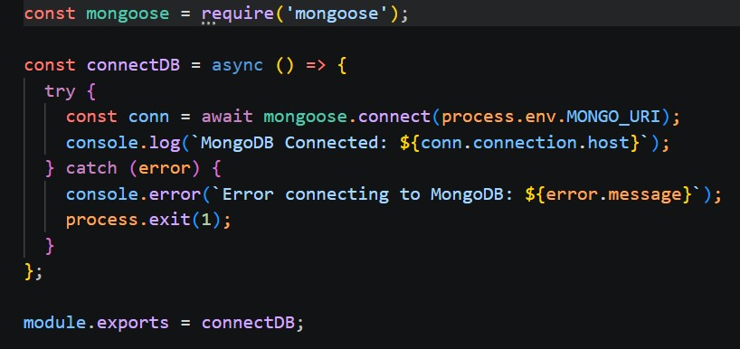

MongoDB Collections
The project mainly uses two collections:

Users Collection
The Users collection stores registered user information.
Main fields include:
- _id
- name
- email
- password
- createdAt
- updatedAt
The password is stored in hashed form using bcrypt.
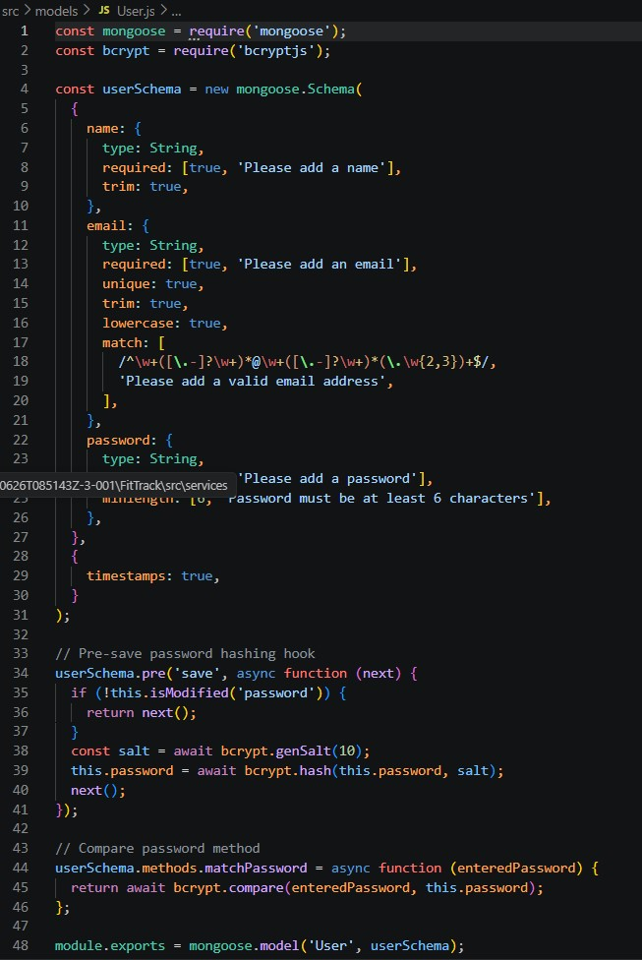

Workouts Collection
The Workouts collection stores the workout records created by registered users.
Main fields:
- _id
- user
- workoutName
- category
- duration
- caloriesBurned
- workoutDate
- createdAt
- updatedAt
The user field stores the ObjectId of the user who created the workout.
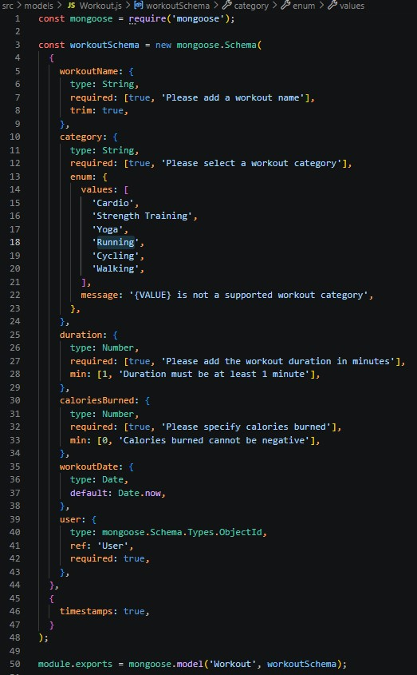

Database Relationship
A single user can have multiple workout records, allowing each account to maintain a separate workout history.
When a user requests their workouts, the backend uses the authenticated user's ID to retrieve and display only the workout records associated with that account.

Database Validation
Mongoose schemas are used to validate data before storing it in MongoDB. Validation ensures required user details are provided, email addresses are unique, required workout fields are present, and each workout is linked to a valid user. The Workout model also ensures that the duration is greater than zero and calories burned are zero or greater.

PROJECT EXECUTION
The AI Fit Track backend is executed locally using Node.js and Express.js. Before running the application, all required dependencies must be installed and environment variables, including the MongoDB connection string, JWT secret, and Gemini API key, must be configured correctly.

Step 1 -- Install Dependencies
Open the project folder in Visual Studio Code and run:
npm install
This command installs all the packages listed in the package.json file.

Step 2 -- Configure Environment Variables
Create or update the .env file with the required configuration values.
PORT=5000
MONGO_URI=mongodb://localhost:27017/aifittrack
JWT_SECRET=your_secret_key
GEMINI_API_KEY=your_google_gemini_api_key
The actual keys and credentials should remain private and should not be uploaded to GitHub.

Step 3 -- Start the Backend Server
Run the backend using:
npm start
After successful execution, the terminal should show that the database is connected and the server is running.

Step 4 -- Test the APIs
After the backend starts successfully, the REST APIs are tested using Postman.
The main APIs tested are:
- Register API
- Login API
- Get Profile API
- Add Workout API
- Get All Workouts API
- Get Workout By ID API
- Update Workout API
- Delete Workout API
- Workout Recommendation API
- Fitness Insights API
OUTPUT SCREENSHOTS:

1. Register API
The Register API creates a new user account using name, email, and password. The password is hashed before being stored in MongoDB.
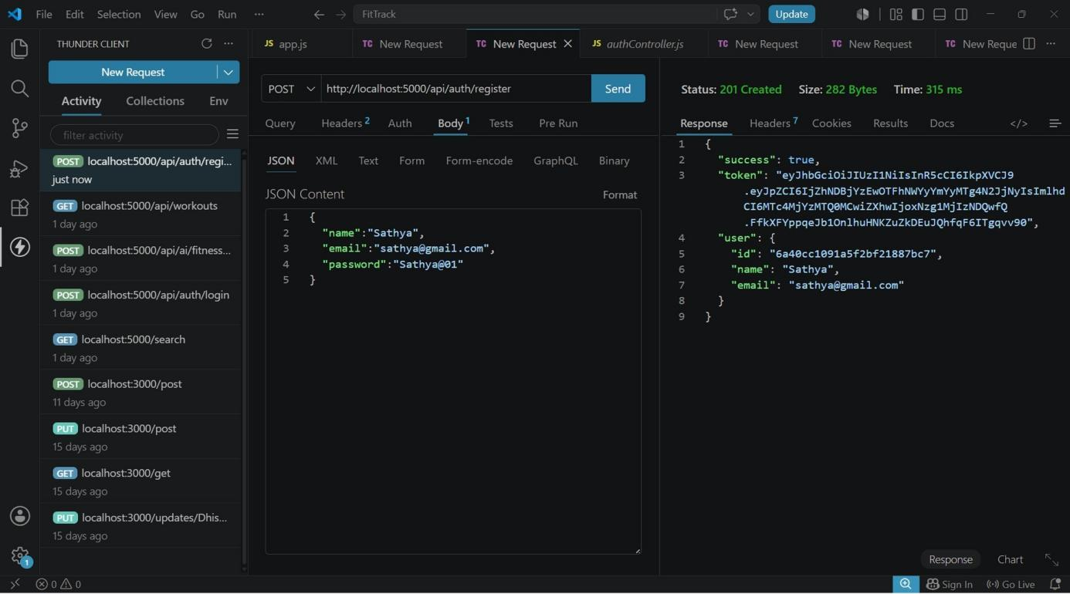

2. Login API
The Login API authenticates an existing user using email and password. After successful login, the system returns a JWT token.
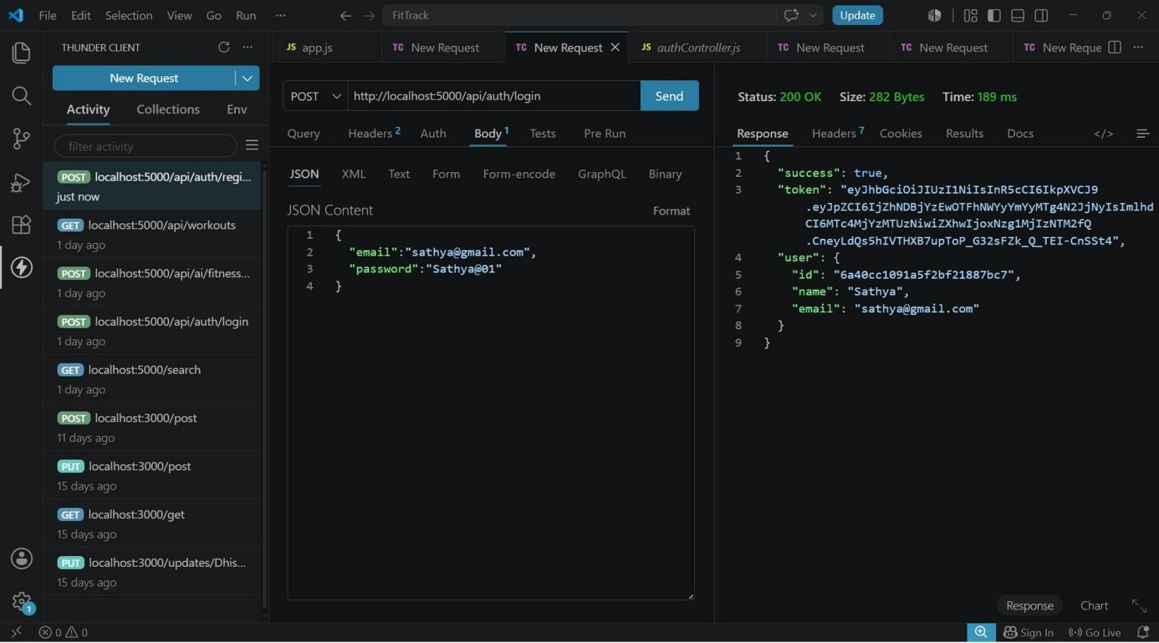

3. Get Profile API
The Get Profile API returns the authenticated user's account information using their JWT token.
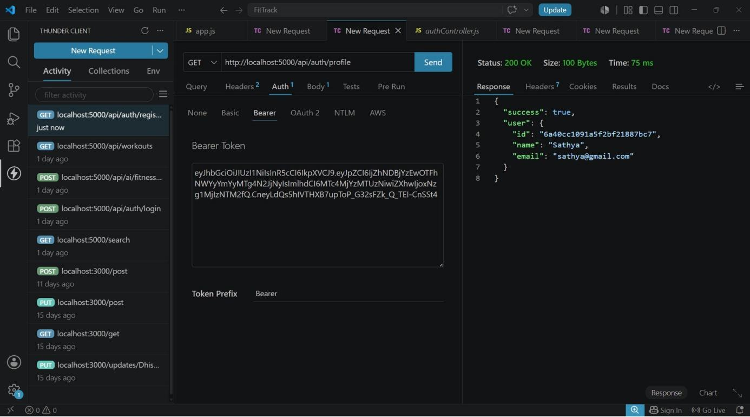

4. Add Workout API
The Add Workout API allows an authenticated user to create a new workout record.
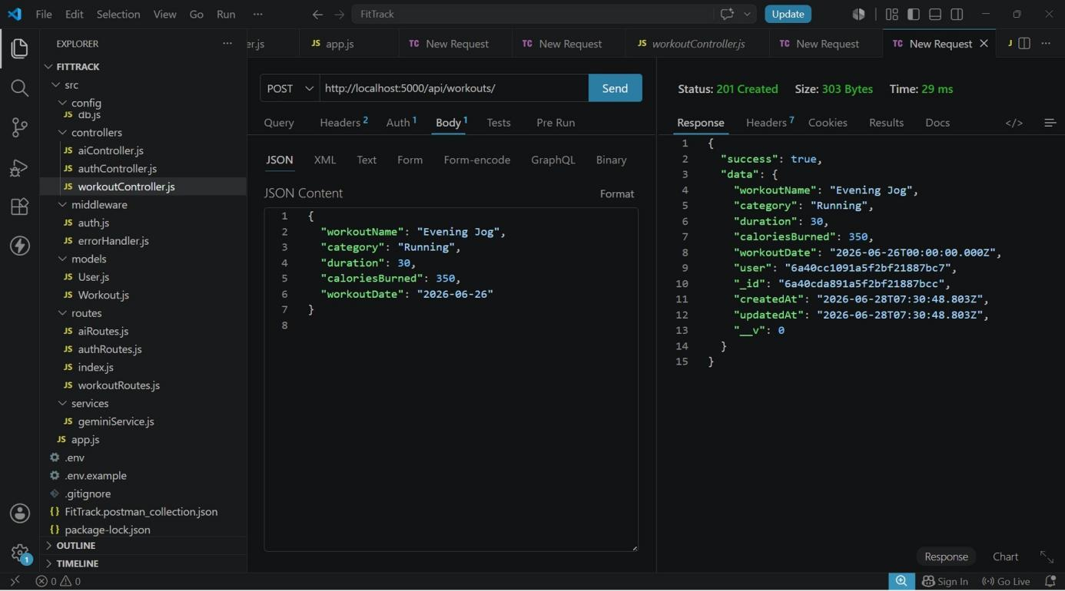

5. Get All Workouts API
This API retrieves all workout records saved by the currently authenticated user.
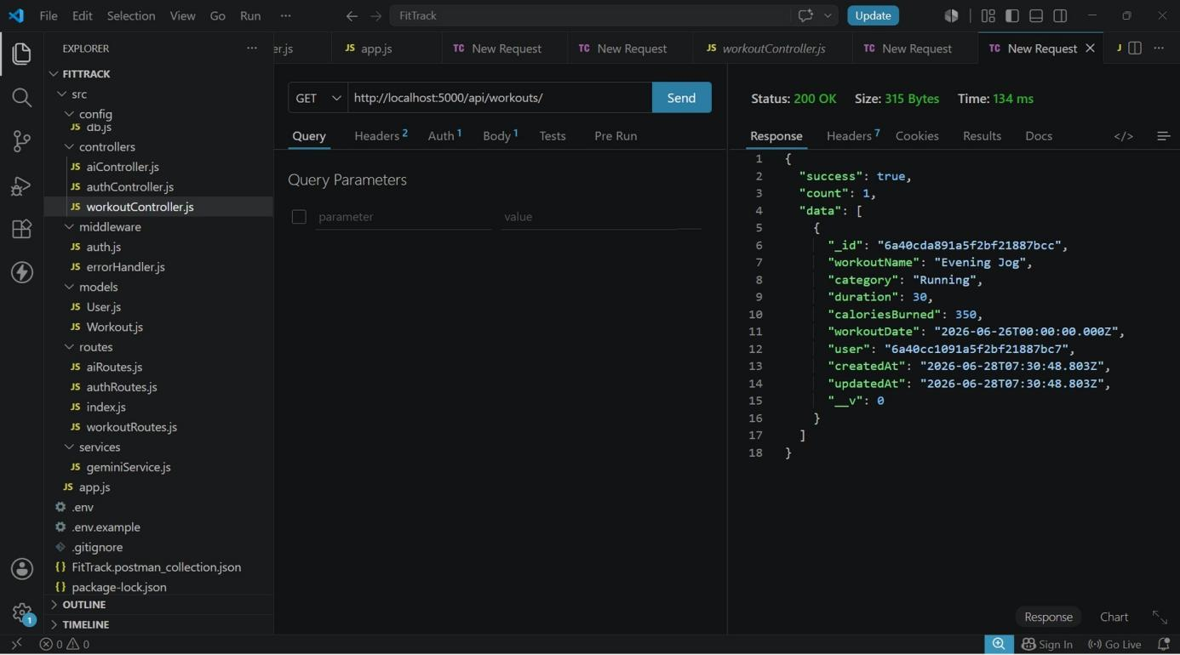

6. Get Workout By ID API
This API retrieves a single workout record using its unique identifier.
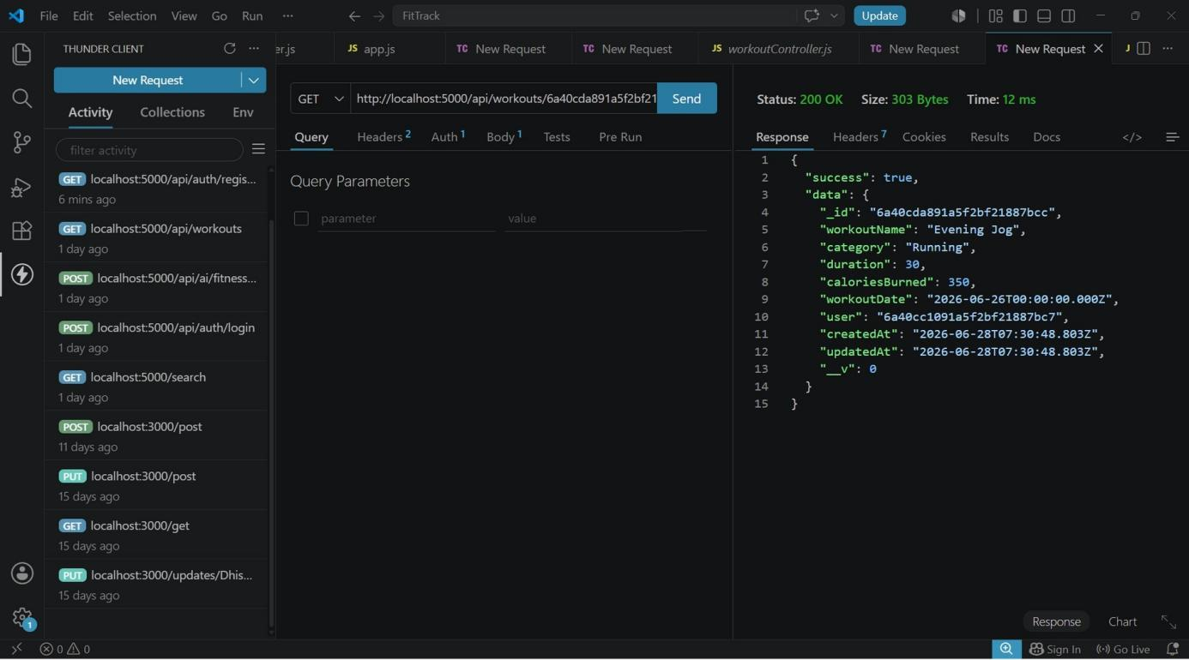

7. Update Workout API
The Update Workout API allows a user to modify an existing workout record.
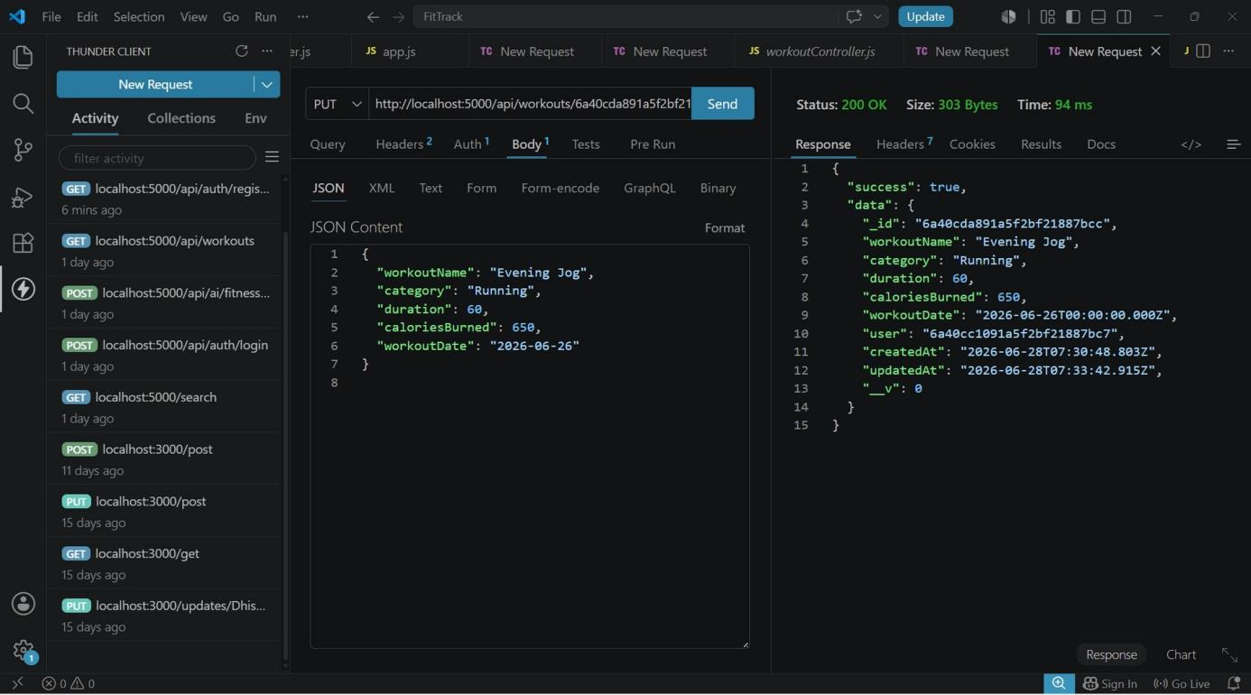

8. Delete Workout API
The Delete Workout API removes a selected workout record from the user's history.
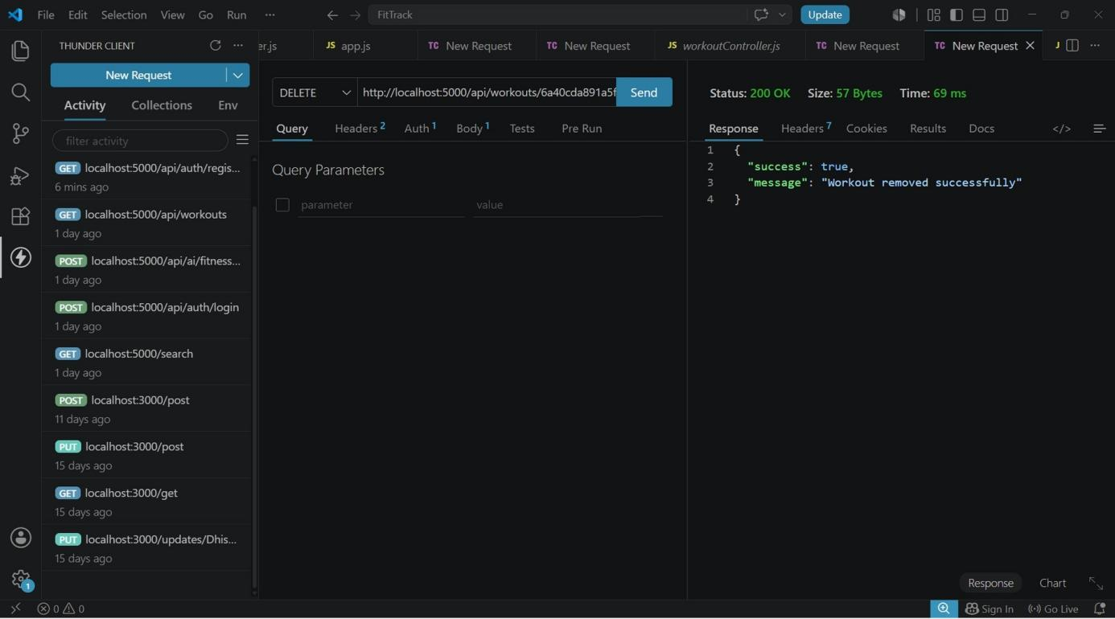

9. Workout Recommendation API
The Workout Recommendation API uses Google Gemini AI to generate a personalized workout plan based on age, fitness goal, and experience level.
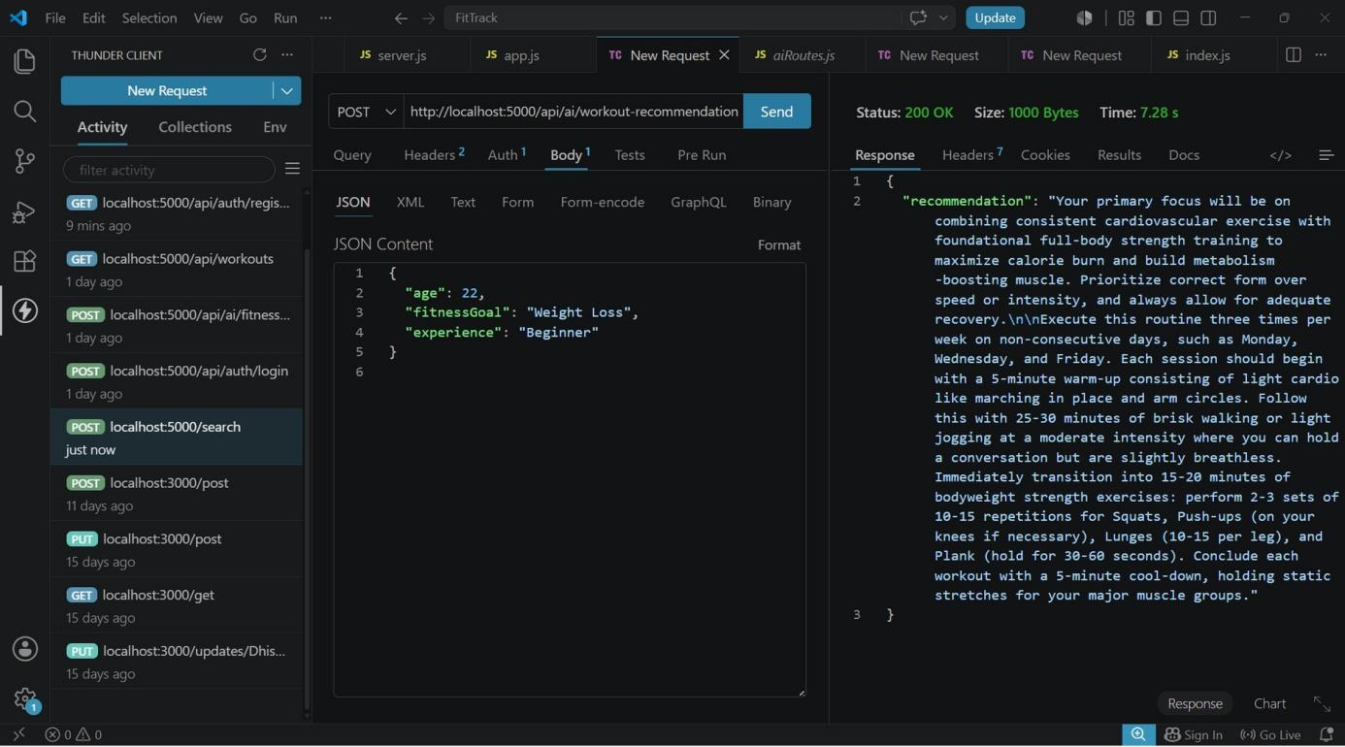

10. Fitness Insights API
The Fitness Insights API analyzes workout statistics and provides performance analysis and motivational guidance.
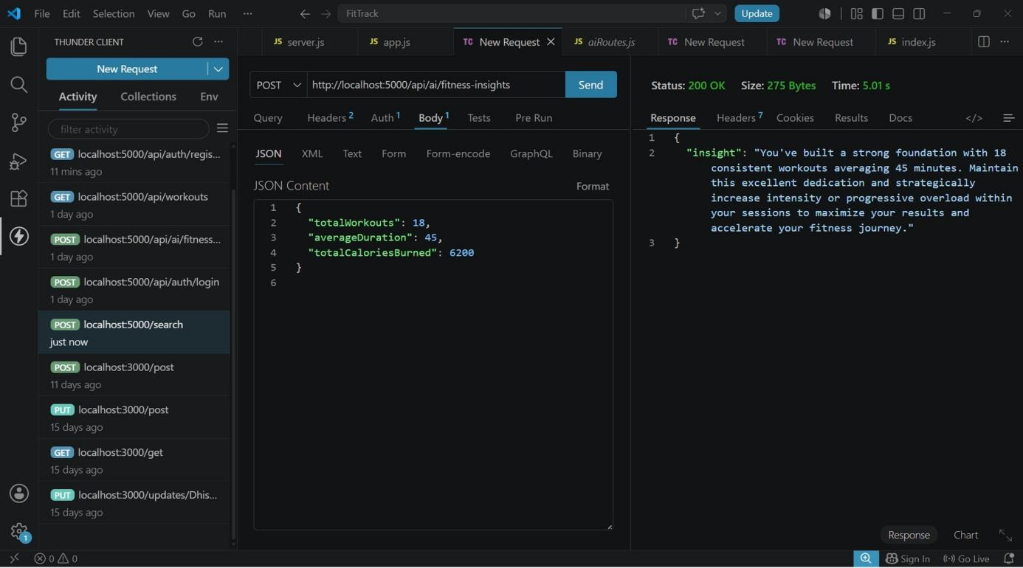

DEMO VIDEO LINK :- https://drive.google.com/drive/folders/1Sgyd2axUOKgbmJ0Disrlh5IwCHwzZZlm?usp=sharing
API TESTING VIDEO LINK :- https://drive.google.com/drive/folders/1I4r32dXGv22zR5QNW3TJONYFoV5DN6jQ

